**STEPS**

1. Open Visual C++ and click the New item in the File menu and a new dialog box is opened
2. Now select “MFC AppWizard (exe)” entry
3. Give the new Project name in the Project name box and click OK. Clicking OK will start the Visual C++ AppWizard

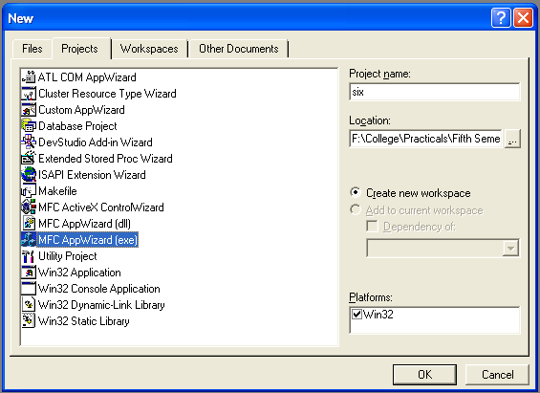

1. We will accept all defaults except one- by default, AppWizard creates Multiple Documents program and we will change so that it creates a Single Document program

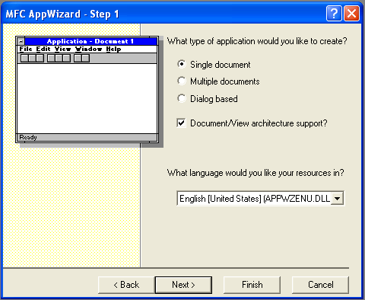

1. The AppWizard is asking for what database we want in our program; we will do “None” option selected. Keep pressing next until project information box is opened.
2. In the document header file, sixdoc.h:

class CSixDoc : public CDocument

{

protected: // create from serialization only

CSixDoc();

DECLARE_DYNCREATE(CSixDoc)

* CString StringData;

.

.

.

.

}

1. Next we initialize the StringData object in the sixdoc.cpp file:

CsixDoc :: CsixDoc

{

* StringData="";

}

1. We then use Class Wizard to add the OnChar() method to the six program view class, CsixView

void CSixView::OnChar(UINT nChar, UINT nRepCnt, UINT nFlags)

{

// TODO: Add your message handler code here and/or call default

* CSixDoc *pDoc=GetDocument();
* ASSERT_VALID(pDoc);
* pDoc->StringData+=nChar;
* Invalidate();

CView::OnChar(nChar, nRepCnt, nFlags);

}

1. The next step is to determine the size of client area, that is our view so that we can centered the typed text in it
2. Now we have to draw the string in the center of the window. So we have to open OnDraw() method from the CSixView class

void CSixView::OnDraw(CDC* pDC)

{

* CSixDoc* pDoc = GetDocument();
* ASSERT_VALID(pDoc);
* CRect rect;
* GetWindowRect(&rect);
* int x=rect.Width()/2;
* int y=rect.Height()/2;
* CSize size=pDC->GetTextExtent(pDoc->StringData);
* x-=size.cx/2;
* y-=size.cy/2;
* pDC->TextOut(x,y,pDoc->StringData);

// TODO: add draw code for native data here

}

1. Now run the program by Build Six.exe and Execute Six.exe item in the Build menu and type some text into it

**OUTPUT**

